Shelf Stable Foods | Shelf life after sell by date
Baby Food | Expiration date on packaging
Canned Foods
High Acid Fruit and Vegetables (Tomato sauce, pickles, applesauce, vinegar based) | 2 Years
Low Acid Fruit (pears, peaches, etc) | 3 Years
Low Acid Vegetables (beans, corn, carrots) | 3 Years
Meat (tuna, chicken, sardines, etc) | 3 Years
Pie Filling | 3 Years
Soups/ Stews/Broth | 3 Years
Condiments, Sauces, Syrups
Barbeque Sauce | 1 Year
Dry Mixes (Gravy, dressing, sauce) | 2 Years
Frosting | 10 Months
Honey | 2 Years
Jams, jellies, ketchup, chili sauce | 18 Months
Mayonnaise | 6 Months
Mustard | 2 Years
Olives | 2 Years
Pickles | 2 Years Jarred  1 Year Canned
Salad Dressing | 1 Year
Salsa | 18 Months
Spaghetti Sauce | 18 Months
Syrup (Corn, Maple, Chocolate) | 2 Years
Vinegar | 2 Years
Worchester Sauce | 2 Years
Dry Goods
Baking Mixes (cakes, brownies, cookies, etc) | 18 Months
Baking Powder | 18 Months
Baking Soda | Indefinite if kept dry
Brown Rice | 1 Year
Bullion (beef, chicken, veggie, etc) | 2 Years
Candy | 36 Months Hard Candy  18 Months Chocolate  9 Months Caramel
Casserole Mixes (Hamburger Helper) | 1 Year
Cereal | 1 Year
Chocolate Chips | Unsweetened 18 Months  Sweet, Semi-sweet 1 Year
Cocoa Powder | 2 Years
Coconut (Dried) | 1 Year
Cookies | 9 Months
Dry Goods Cont.
Cornmeal | 1 Year
Crackers | 6 Months
Croutons | 6 Months
Dried Beans | 1 Year
Evaporated Milk | 1 Year
Gelatin | 18 Months
Grits | Instant 8 Months  Regular 10 Months
Jerky (Beef, Chicken, Pork, Etc) | 1 Year
Mac & Cheese | 1 Year
Marshmallows | 3 Months
Nuts | 1 Year
Nutella | 1 Month
Pasta | 2 Years
Peanut Butter | 18 Months
Potato Flakes | 1 Year
Popcorn | Kernels 2 Years  Microwave Packets 1 Year  Commercially Popped 3 Weeks
Pretzels | 8 Months
Pudding Cups | 1 Week
Pudding Mix | 1 Year
Oatmeal | 1 Year
Oils | Vegetable, Canola, etc. 2 Years  Olive 6 Months
Shortening | 1 Year
Spices | Whole 4 Years  Ground 2 Years
Stuffing Mix | 1 Year
Sugar (Brown and Confectioners) | 18 Months
Sugar | Substitute (Stevia, Splenda, Sweet & Low) 2 Years  White 2 Years
Sweetened Condensed Milk | 1 Year
Toaster Pastries | No Fruit 9 Months  Fruit 6 Months
Tortillas | Hard Shells 1 Year  Flour and corn 1 Week
Tortilla Chips | 3 Months
White Rice | 2 Years
Yeast | Expiration Date on Package
Beverages
Coffee | Instant 2 Years  Whole Bean 6 Months  Ground 5 Months
Coffee Creamer | Dry 2 Years  Liquid 1 Year
Hot Chocolate Mix | 1 Year
Juice | Canned Non-Citrus 1 Year  Bottled 9 Months  Boxes 6 Months  Canned Citrus 6 Months
Milk | Shelf Stable 1 Year  Rice 6 Months  Almond 4 Weeks
Powdered Milk | 2 Years
Soft Drinks | 9 Months
Tea (Loose, Bags, and Instant) | 2 Years

Discard the following:

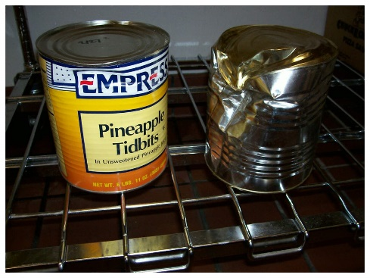
- Cans with dents on the top or the bottom
- Severe side dents
- Cans missing labels
- Bloated Cans
- Leaking/punctured cans
- Rusted cans
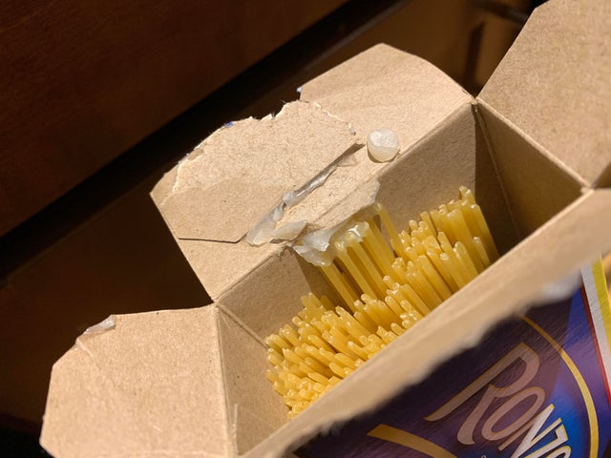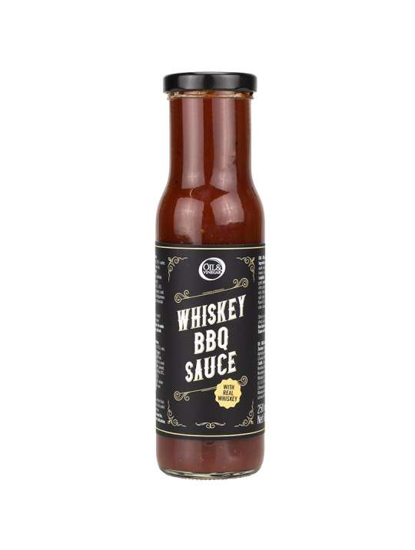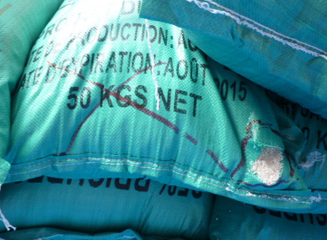
- Opened containers
- If it has internal packaging, make sure it is intact and tape box closed
- If air can get to the food, throw it away!
- Rips/Tears in bags
- If taped over, throw away
- Alcohol flavors and logos
- Anything with actual alcohol in it

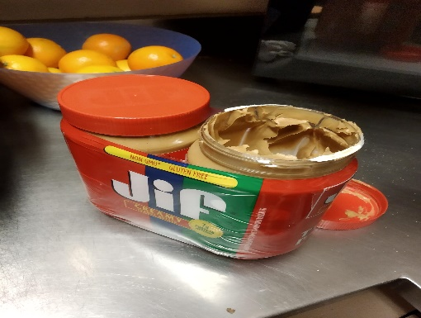
- Jars missing safety seal
- ALWAYS check for the seal unless there is an outer safety seal
- If glass jar lids “pop” throw it out
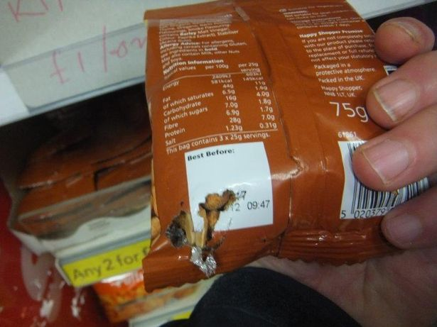
- Signs of pests
- Gnaw marks
- Droppings
- Dead/Living creatures (Yes, it happens)
- Throw away all items that seem to be in contact with pests
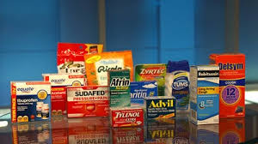
- Any medication
- Any supplements
- Any items with supplemental facts or drug active ingredients
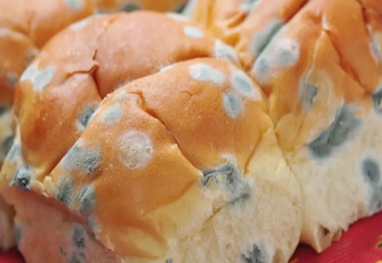
- Signs of mold
- Bad odors
- Unusual liquids

If in doubt, ASK

